August 2020

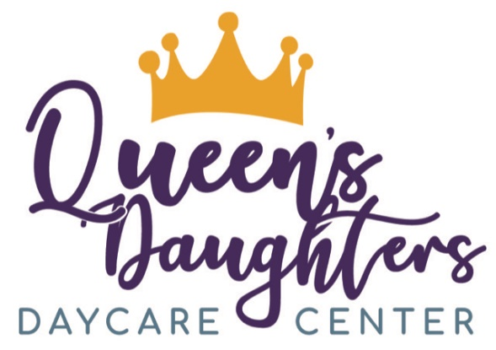
Queen’s Daughters Daycare Center
Pandemic Policy and Procedures
Response to COVID-19

What is COVID-19?

- The virus that causes COVID-19 can infect people of all ages. COVID-19 is spread from person-to-person through contact that is close enough to share droplets generated by coughing, sneezing, speaking and even breathing. COVID-19 can also be spread by touching objects where contaminated droplets have landed. Because of this easy manner of transmission, an infant, child or young person who is infected with COVID-19 can spread the infection to others they come in close contact with, such as members of their household, teachers, or other caregivers. Infected persons with mild or even no symptoms can spread COVID-19. The COVID-19 pandemic has presented unexpected challenges to childcare centers across the world.

This guide was created to ensure the health and safety of all staff members, families, and children. Following specific guidelines from the CDC, you will notice drastic changes in our day-to-day routines, classroom procedures, and even the way in which we communicate with parents.

Health Procedures

- To ensure the well-being of all of our families, staff members, and children, we will have to undergo new safety policies.

- As long as you are in the building, a mask MUST be worn at all times. Handwashing and sanitizing should be done at the following times:

- Upon entering and leaving the building
- When children have arrived for the day
- Before and after feeding times
- Before and after bathroom routines
- Sanitizing of the toys should happen every day during nap time
- Surfaces and counter tops are to be sanitized after every use
- Before and after your lunch break
- After coming in contact with bodily fluids
- Before and after outdoor play
- After handling garbage
- Before and after playing in sand, water, or engaging in other sensory activities.

- Staff members are prohibited from congregating in the staff lounge. Water, coffee, and other grab and go materials will be available to you all throughout the day, but you will not be able to take your lunch break in the staff lounge due to CDC guidelines.

- Children and staff are prohibited from bringing items from home into the center, including toys, reusable water bottles, etc. The only items permitted to be brought from home by children and staff is bedding for nap time, sippy cups for children under the age of 3 years old, and one change of clothing in a labeled plastic zip-lock bag.

- Children will NOT be allowed to transport their bookbags back and forth from home to school daily. On Friday’s, they will be able to take home their belongings (clothes, blankets) to launder and return to school the following Monday.

Sick Policies

- Every staff member and child will have their temperatures taken and documented every day upon arriving to the center.

- Any staff or child will be sent home if they present with any of the following signs or symptoms of possible COVID-19:
- Feeling feverish or a measured
- Temperature greater than or equal to 100.0 degrees Fahrenheit
- Vigorous or dry cough
- Shortness of breath or difficulty breathing
- Sore throat
- Chills
- Loss of taste or smell
- Diarrhea
- Repeated shaking with chills
- Muscle pain
- Headache
- Runny Noses
- Has had close contact with a person who was lab- confirmed to have COVID-19

- Any staff member, child, or parent that has notified the center of these potential symptoms, must be monitored and home for 72-hours and tested for COVID-19.
- The staff member, child, or parent will not be allowed entry into the center until a negative test result is provided by a pediatrician/ medical doctor without the use of fever-reducing medications, or the individual has improvement in respiratory symptoms (e.g., cough, shortness of breath), and at least 14 days have passed since symptoms first appeared.

If COVID-19 is confirmed (tested positive) in a child, staff member or other adult who has been present in the center, the center will:
- Follow CDC guidance on how to disinfect the center by cleaning and disinfecting all areas used by the person who is sick, such as classrooms, offices, bathrooms, and common
- areas.
- Contact our regulatory agencies for further guidance when necessary.
- Continue routine cleaning and disinfection.

Social Distancing

- Our main focus here at Queen’s Daughters is to ensure the health and safety of everyone in our center. Social distancing guides will remain in effect for both staff, parents, and children.

- Face covering, hand hygiene, cough etiquette, cleanliness, and sanitation will be rigorously practiced.
- Children will be assigned to the same classroom each day and staff rotation will be limited among the same group.
- Each group of children will stay in a separate room, to the extent possible.
- Special events such as festivals, holiday events, and special performances will be canceled or postponed.
- We will do our best to socially distance the children while in the classrooms, on the playground, and in the gym. The classroom ratios will be smaller than normal to follow social distancing rules.

Curbside Drop off & Pick Up

- Under any circumstances will the parents be allowed into the center for any reason.
- During these times, a mask MUST be worn by EVERYONE in order for us to retrieve children.
- Our arrival cut off time each morning is 9am unless a parent or guardian has notified the school office.
- A drop off and pick up routine will be established at the time of our reopening and staff members will be assigned multiples tasks to help this transition run smoothly as possible.
- We will have an unlimited supply of masks, shields, gloves, and sanitizers available for usage every day.
- We ask your patience and cooperation during this procedure as it will be daily and indefinitely for everyone’s safety.
- Cash payments will NOT be accepted. One of the staff outside during drop off and pick up will accept checks or money orders from parents.
- We still ask that you maintain 6-feet apart during this procedure.

Enhanced Cleaning and Sanitizing Procedures

- Any toys that cannot be sanitized or cleaned WILL NOT be used.
- No outside toys or objects of any kind will not be allowed into the center.
- Harmful disinfectants will not be used around children
- Each classroom will have their own bleach and water solution as well as soap and water bottles that will be changed every morning.
- All areas, bathrooms, changing stations, and feeding materials will be thoroughly sanitized twice a day.

`Feeding and Meal Preparation Procedures

- Every meal will be dished out and proportioned individually from kitchen staff.
- Plastic utensils and dishware will be utilized until further notice
- Children under 2 years old will use metal silverware designated per child and their materials will be labeled strictly for their usage.
- No outside foods are permitted, unless it’s baby formula or if your child has a documented food allergy.

Parent/ Staff Agreement

Here at Queen’s Daughters, we ensure the utmost safety and healthy environment for everyone that enters the center.

By signing below, you are adhering and cooperating with our COVID-19 response procedures.

Signature:______________________________
Date:_________________________________

